## Commands Utilities

This assignment expects the participant to identify specific command(s) OR perform the given action using one or commands as per the given question. You are requested to maintain the answers (i.e command(s) as per given question) for all questions below.

**Mandatory Questions**

1. Which command is used to know the current working directory?

Ans. By using the command **Pwd**.

1. How would you find out its contents?

Ans. By using the command **ls**.

1. Identify the commands with inputs to do the following
   1. create a directory d1

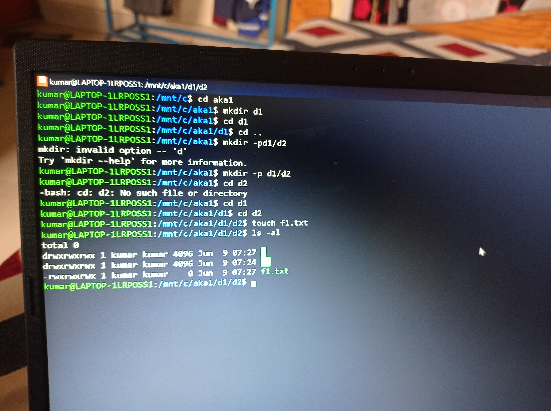

* 1. create a subdirectory d2 in d1



* 1. change to directory d2
  2. create an empty file “f1.txt”



* 1. display the contents of “f1.txt”

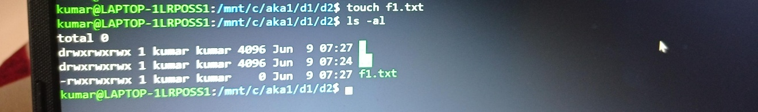

* 1. view the contents of d1 from current directory d2

ans. Cat d1 d2

1. Use the ls command with its options. How will you identify directories from the listing?

Ans . ls

1. Use ls to do the following
   1. List files with single character names.
   2. List hidden files also. [ Note : Hidden files are files having name started with a “.” ]

Ans. In such case we have to use ls –al [a .*]

* 1. Suppose there are files tb1.1, tb2.1, tb3.1, ….tb10.1. Write command to list all the files [Hint: use wild card characters]

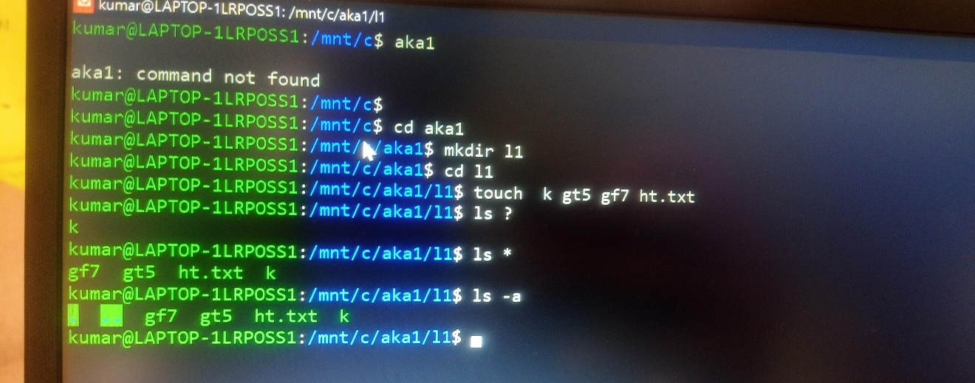

1. Write the command to list all files in descending order of their size.

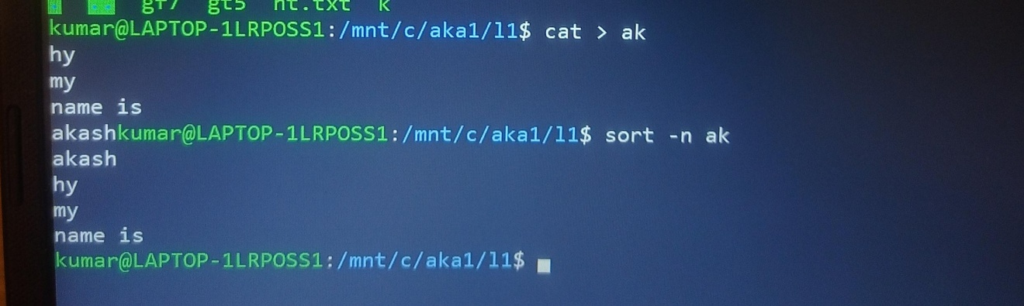

1. Suppose there are files temp1, temp2, temp3. Write command to remove the files without listing them explicitly

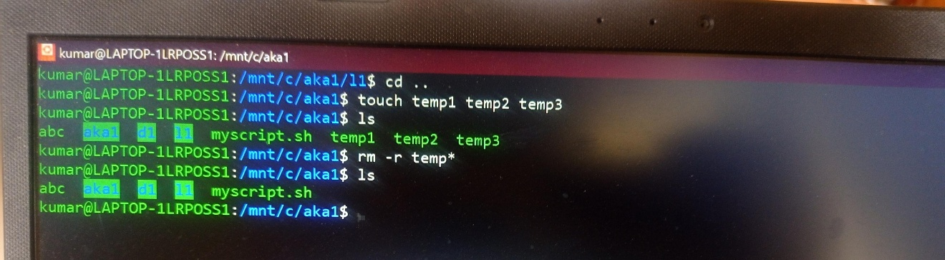

1. Which command is used to list top few lines in the file?

Ans.the haead comm

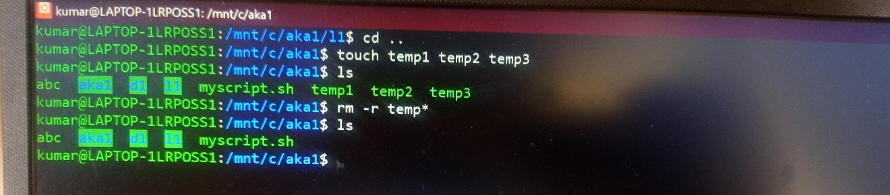

1. Create a directory “testdir”

Ans. mkdir testdir

1. Use cp command to do the following
   1. Copy the file tb1.1 (created above) in the same directory.
   2. Write a command to copy all the files i.e tb1.1,tb2.1,tb3.1,…..tb10.1 in a new directory –“new”
   3. Create a subdirectory in new in named“new1”.
   4. Write a command to copy selectively only tb2.1, tb6.1, tb7.1 and tb10.1 in the directory new1.
   5. Write a command to copy the entire directory “new” to a directory “newprogs”. [Note : use the –R option of “cp” command ]
2. Find out the difference between
   1. “mv” & “cp” = move & copy
   2. “rm”, “rmdir” =remove file & remove directory
   3. “mkdir” and “mkdir -p”= create directory and create parent directory
3. Use a single command rmdir once to remove “testdir” and all its sub directories and files created above.
4. Which command is used to get the manual information of a command?

Ans . man

1. If you are not able to change to a directory what could be the likely cause?

It may happen that you are trying to cd into a file. The same message is thrown then. This may happen when something that you think should be a directory, is a file in reality. Well, Permission denied and Not a directory are different errors,and both describes what's wrong pretty clearly

1. Explain the differences among the following commands:  
                 a. cd /

  b. cd ..= it moves your directory to 1 level up

  c. cd =to go to any directory

  d. cd ../..  comes to the parent directory

**Advanced Optional Questions**

1. How could you display the inode number of a file?
2. What is the pipe symbol? What effect does it have?
3. Find out the details of “ps” command ?